### Week 1 Forum Posting

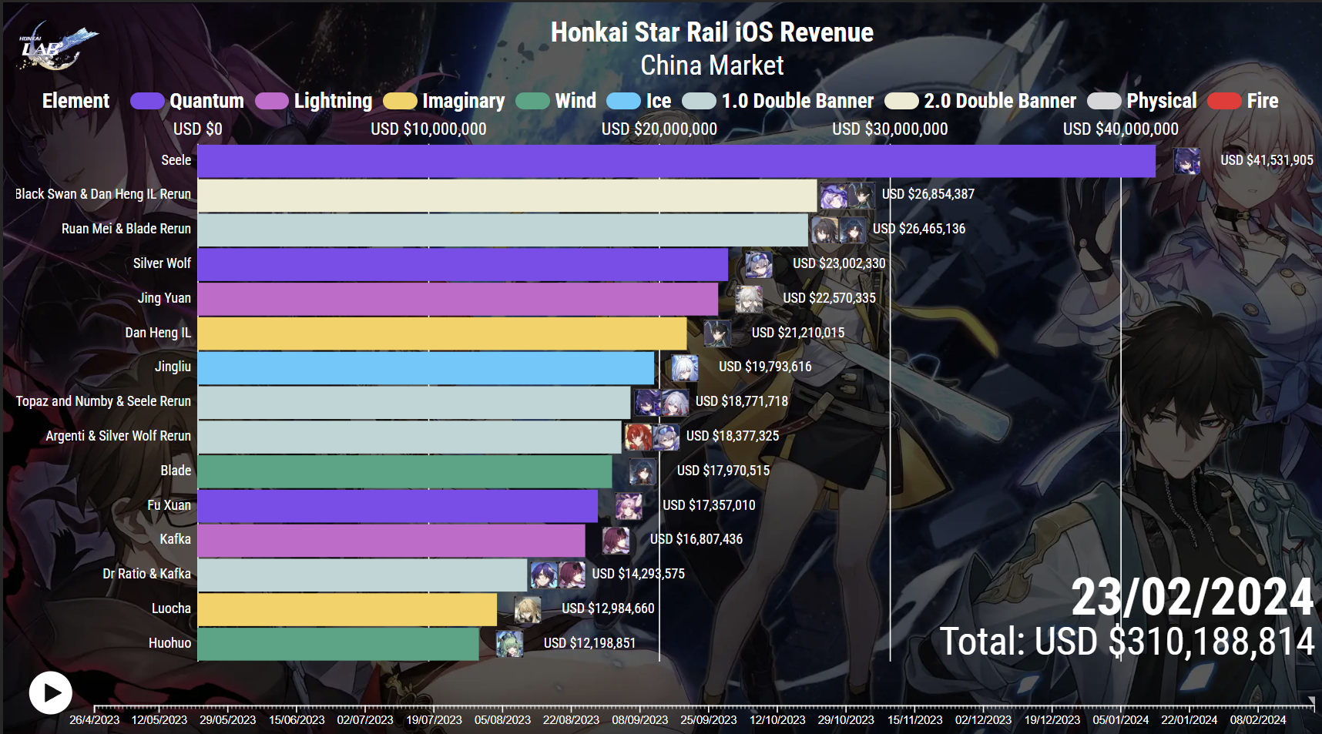

Image Source: https://honkailab.com/honkai-star-rail-revenue-chart/

**What? Why? How? framework by Munzner**

**What**

The graph visualisation shows the revenue in USD for different characters’ elements and banners in the game Honkai Star Rail.

**Type of dataset**: Tables. 2D. Each banner has its own value of total revenue obtained from the said banner.

**Ordered & Qualitative data:**

* **Quantitative:** 
  + The bars represent revenue in USD, which is a measurable and comparable quantity.
  + The different years (2023 to 2024) are qualitative as they categorise the data points.
* **Ordinal**: The data is ordered by year, showing a progression over time from 2023 to 2024.
* **Categorical**: Different characters in each banner possess different elements.

**Attributes**: Revenue in USD for different characters’ elements path and banners in the game Honkai Star Rail.

**Why**

The purpose of the graph visualisation is to analyse and compare the revenue generated by different elements and banners in the game. This helps in understanding which elements are more favoured or profitable by the players. The higher the revenue within the banner period implies that the character(s) are more likely favoured by the players. The reason on why the characters are more favoured arise from many factors such as the character(s)’ kit, playstyle, visual/design or just pure player personal favourites.

**How**

**Marks**: Horizontal bars representing revenue for each element and banner.

**Channels**:

* Position: The y-axis lists the elements and banners (qualitative data), and the x-axis represents revenue in USD (quantitative data).
* Colour Hue: Different colours for each bar to distinguish between elements and banners.
* Length: The length of each horizontal bar indicates the amount of revenue generated for each banner.
* Labels/Annotation: The labels/annotations added at the end of each bar are additional notes or comments added to the visualisation to highlight important information or provide further explanation like in the image is the total revenue for the banners

### Week 2 Forum Posting

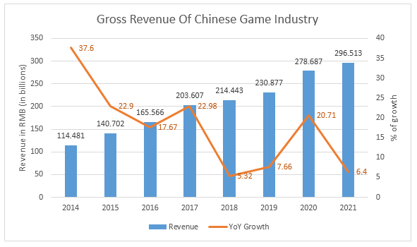

Image Source: https://www.cocos.com/en/post/chinas-game-industry-grows-in-2021-what-will-happen-in-2022

**Visualisation Idiom:** Combination bar and line chart.

**Is the visualisation idiom a good choice?**

Yes. From my perspective, based on the information provided, this particular chart is suitable for presenting two distinct datasets simultaneously, facilitating a comparison between the two sets of data. The blue bars in the visual graph show the gross revenue of the Chinese gaming industry in billions of RMB, while the orange line depicts the year-over-year growth percentage. The orange line clearly displays the YoY growth trend, making it simple to distinguish between periods of high and low growth. It's important to understand that dual-axis charts can create a misleading connection between two sets of data if the scaling or interpretation is not accurate, despite having a shared axis, the graph effectively displays the data. Therefore, utilising the visualisation idiom is a suitable option for the data.

**What? Why? How? framework by Munzner**

**What**

The graph visualisation shows the gross revenue in RMB in billions and percentage of year-over-year growth from year 2014 to 2021.

**Type of dataset:** Tables. Each year gross revenue in the chinese gaming industry is represented by each bar in the bar chart.

**Ordered & Qualitative data:**

* **Quantitative:** The bars represent revenue in RMB (in billions), which is a measurable and comparable quantity. The data is ordered by year, showing a progression over time from 2014 to 2021.
* **Ordinal:** The YoY growth percentages are also ordered, showing the trend of growth rates over the same period.
* **Categorical:** The different years (2014 to 2021) are qualitative as they categorise the data points.

**Attributes:** Gross revenue in RMB (in billions) and percentage of year-over-year (YoY) growth from 2014 to 2021.

**Why**

The purpose of the graph visualisation is to analyse the financial performance of the China game industry over time. This visualisation helps in understanding both the absolute revenue figures and the relative annual growth trends for the game industry in China. The higher the gross revenue earned each year is represented by one blue bar and if the length of the bar is longer, it indicates that the gross revenue earned in that said year is higher the year that has a shorter bar.

**How**

**Marks:** Bars representing the gross revenue for each year. Lines representing the YoY growth percentage.

**Channels:**

* Position: The x-axis represents the years (qualitative data), and the y-axis on the left represents revenue in RMB (quantitative data), while the y-axis on the right represents YoY growth percentage (quantitative data).
* Colour Hue: Different colours for bars and the line to distinguish between revenue and YoY growth.
* Height/Length: The height of the bars indicates the revenue amount, and the position of the line indicates the YoY growth percentage.
* Labels/Annotation: The labels/annotations added at the end of each bar are additional notes or comments added to the visualisation to highlight important information or provide further explanation like in the image is the total revenue for the games in China gaming industry for each year

### Week 3 Forum Posting

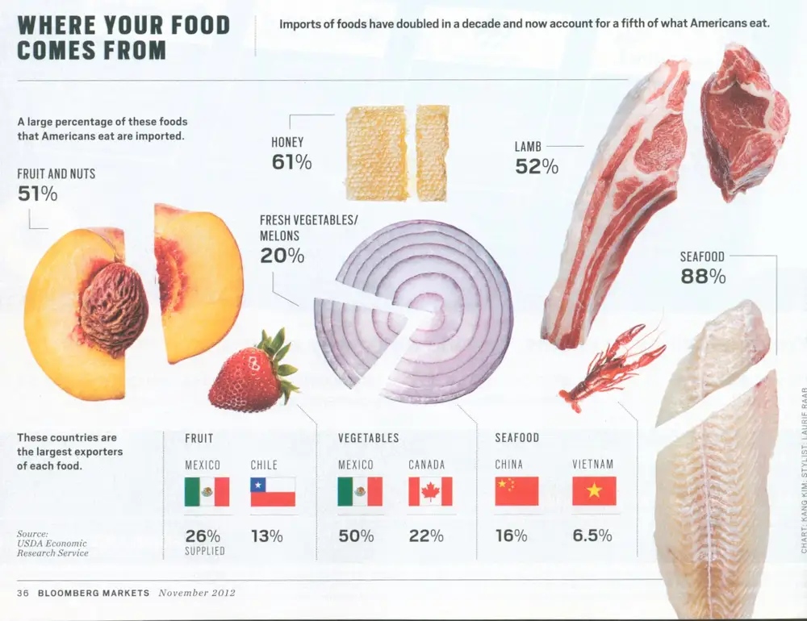

Image Source:

https://www.businessinsider.com/the-27-worst-charts-of-all-time-2013-6#i-never-thought-it-was-possible-but-i-actually-understand-soccer-less-after-looking-at-this-chart-3

**Why is it lying?**

* Misleading Visuals: The pictorial representations do not accurately reflect the proportions of the data. For example, the size of the honey image might be larger than the lamb image, even if the data suggests otherwise.

**How to fix it?**

* Proportional Representation: Use bar charts with consistent scaling to accurately represent the data values.

**Data-ink ratio and how to improve it?**

* The graph has a low data-ink ratio due to excessive use of decorative images and textures.
* **Improvement**: Remove non-data ink such as decorative images and textures. Use simple lines or bars with minimal colour to convey information effectively.

**Chartjunk**

* Decorative images of food items and textured backgrounds that distract from understanding the actual import figures.

**Storytelling**

* **Context**: The graph aims to show the percentage of food imports in the U.S. and the major exporting countries.
* **Genre**: Informational graphic targeting readers interested in economics, trade, nutrition, or food industry trends.

.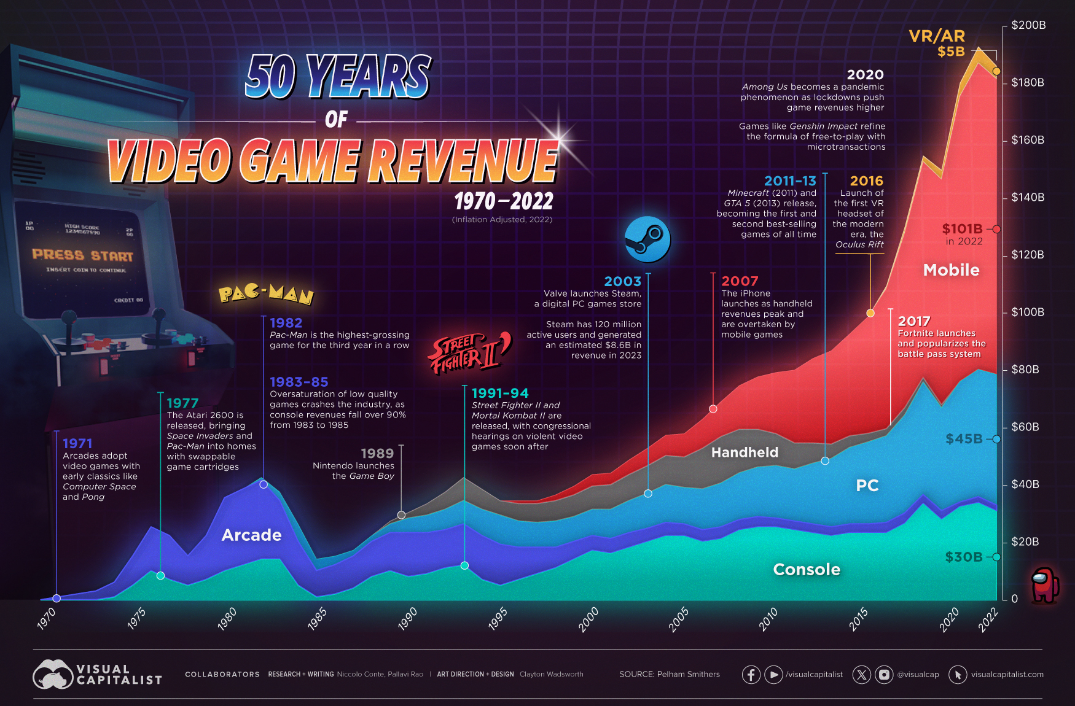

Image Source:

https://www.visualcapitalist.com/video-game-industry-revenues-by-platform/

### Week 4 Forum Posting

| Find a partitioned poster or another rather complex multi-component visualisation with an interesting layout and creative use of typography and colour. Analyse the following aspects in not more than 200 words:  **Colour**: How is colour used to show quantitative and qualitative information? What can be improved regarding the use of colour?  **Layout**: Identify the sight lines used. Critique the layout (balance, visual centre, alignment, white space). What could be improved?  **Typography and label placement**: What kind of typefaces are used? Suggest an alternative non-standard typeface for this visualisation. How are weight, size and other type characteristics changed to create visual hierarchy and highlight information? Can the placement of annotations be improved?  Do not use a visualisation that another student has already posted on the forum. Do not use a visualisation included or mentioned in the lecture, textbook, required or optional readings, or any other source discussed or shown during any unit activity. You must find an existing visualisation and not create a new visualisation. |
| --- |

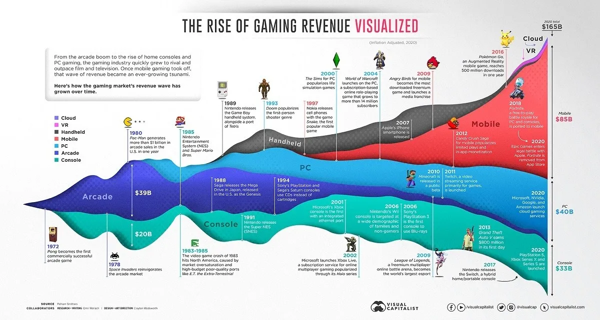

Image Source:

https://medium.com/@aarav999/evolution-and-transformation-of-gaming-industry-b4728747e38e

**Graph Description**:

This graph effectively shows the rise of gaming revenue over time, particularly the dominance of mobile platforms.

**Colour Usage**:

* The graph uses distinct colours hues for different gaming platforms: cloud, mobile, handheld, PC, console, and arcade.
* Quantitative Information: Larger areas represent higher revenues, while smaller areas indicate lower revenues.
* Qualitative Information: Each colour represents a specific gaming platform.
* Improvement: People with colour vision deficiencies might not be able to identify the difference in colour hues for each gaming platform.

**Layout and Sight Lines**:

* The sight lines follow the flow of the ribbons horizontally across the page.
* **Balance**: The layout seems balanced where each platform's ribbon has proportional space.
* **Visual Centre**: The centre of the graph lacks a clear focal point. Adding a visual centre like for example to emphasise a specific year or gaming platform could enhance user readability.
* **Alignment**: The ribbons align well horizontally, but vertical alignment could be improved for consistency.
* **White Space**: The edges could benefit from more white space to prevent crowding of information and enhance visual clarity.

**Typography and Label Placement**:

* **Typefaces**: Sans-serif typefaces are used throughout for clarity and modernity.
* **Alternative Typeface**: Consider using "Montserrat Alternates," which offers various weights and styles for engaging hierarchy.
* **Visual Hierarchy**: Larger font sizes for platform names create hierarchy. Smaller sizes for specific figures maintain readability.
* **Annotations**: Some annotations directly on ribbons may clutter the graph. Using leader lines or offsetting annotations could improve clarity.